Hybrid renewable energy storage system

Steady and continuous

1. There are four types to product solar heat and transport into electricity power system directly.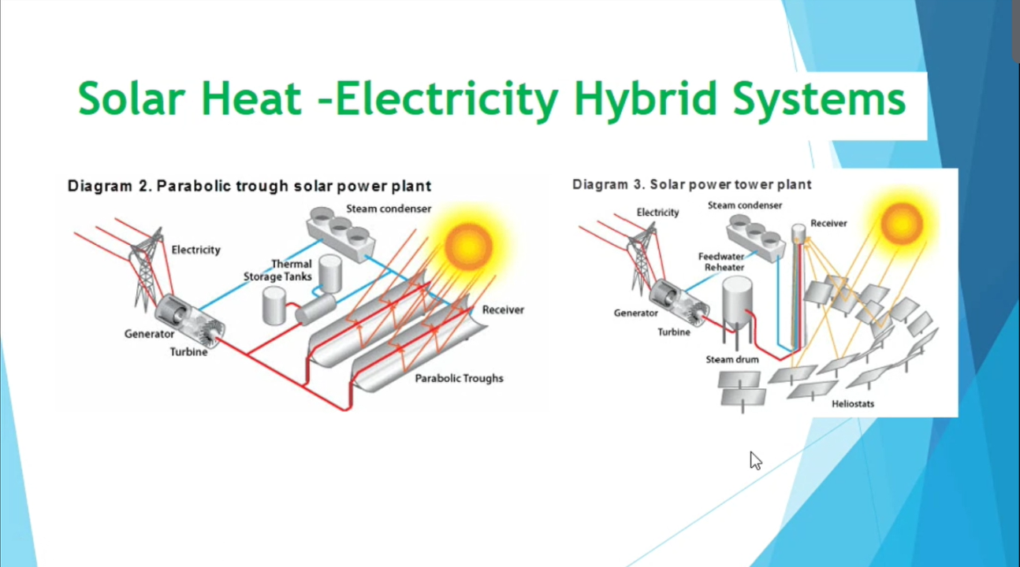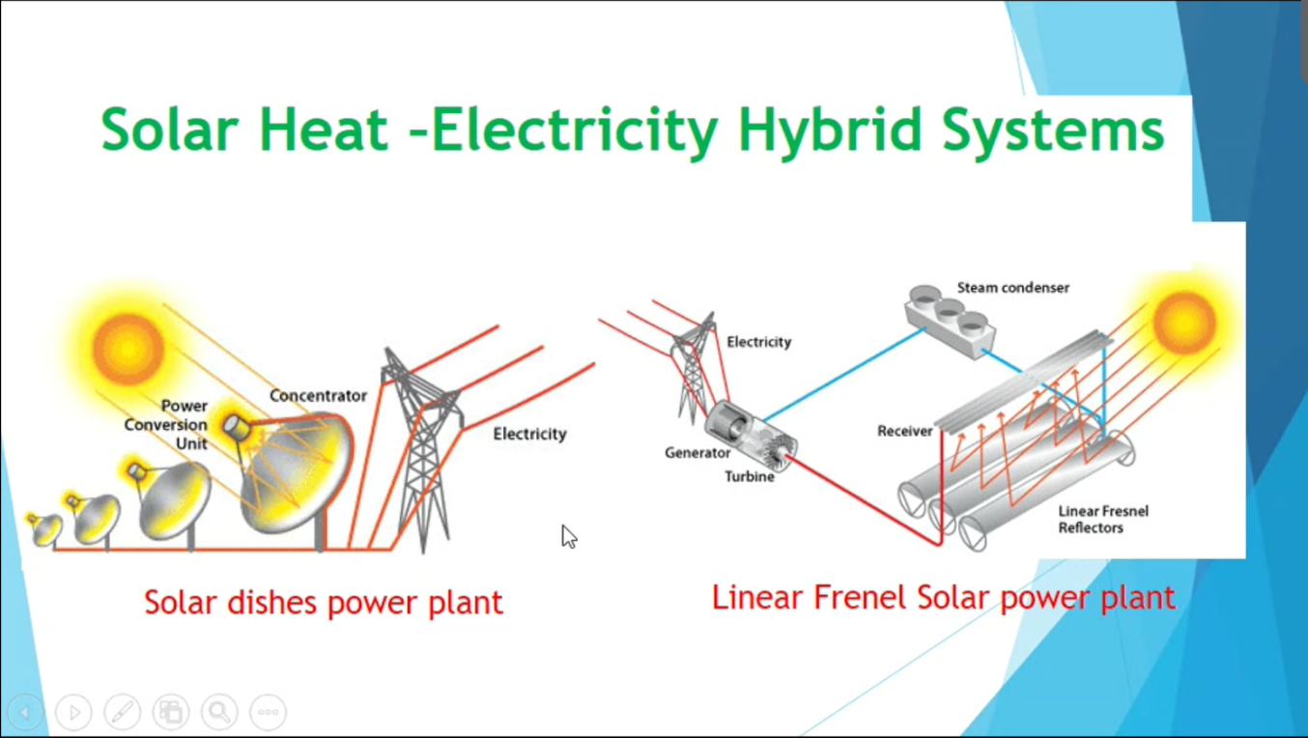

But in somewhere, there aren’t having power system, so some people think the solar power can be transform into Hydrogen gas. Using solar power make the electrolyzer product hydrogen, and storge in tank with high pressure.It easy to storge, low pollution and cheap, can be used on bus, truck, mobile, etc.

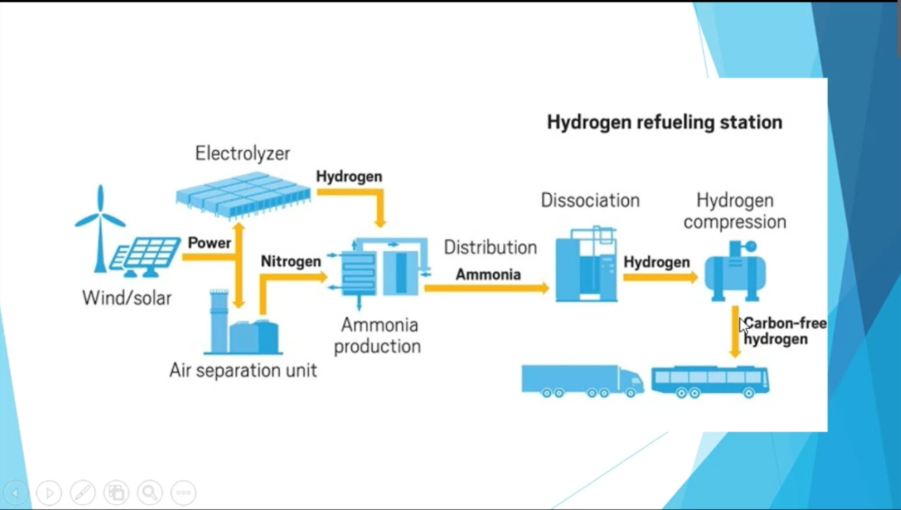

Or use wind power to product hydrogen on the sea.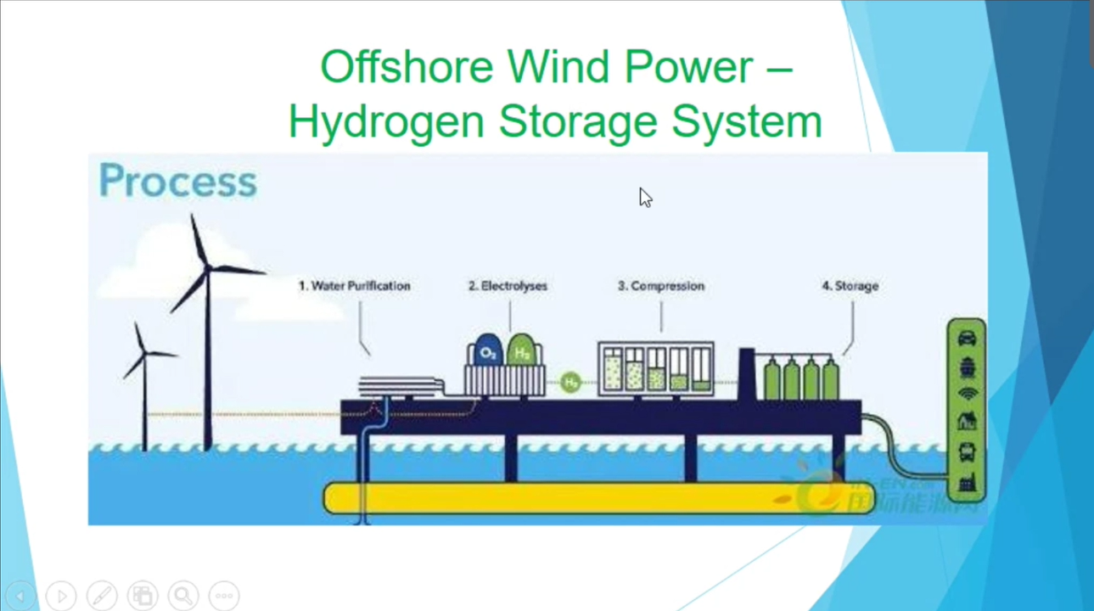

1. Thermochemical process:
2. Natural gas refoeming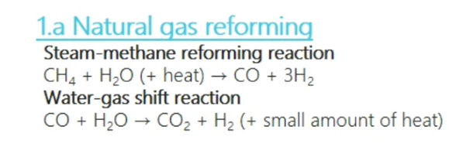
3. Biomass gasification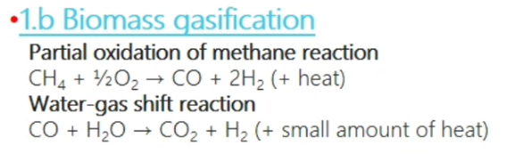
4. Biomass-derived liquid reforming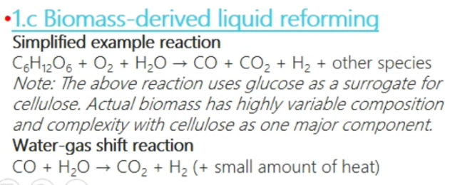
5. Solar thermochemical hydrogen (STCH)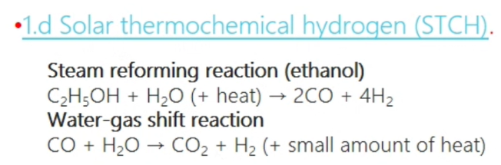
6. Electrolytic process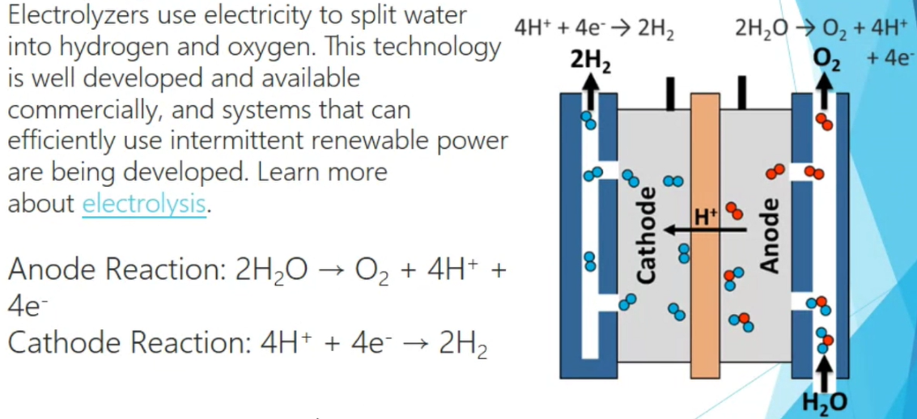
7. Direct Solar Water Splitting Process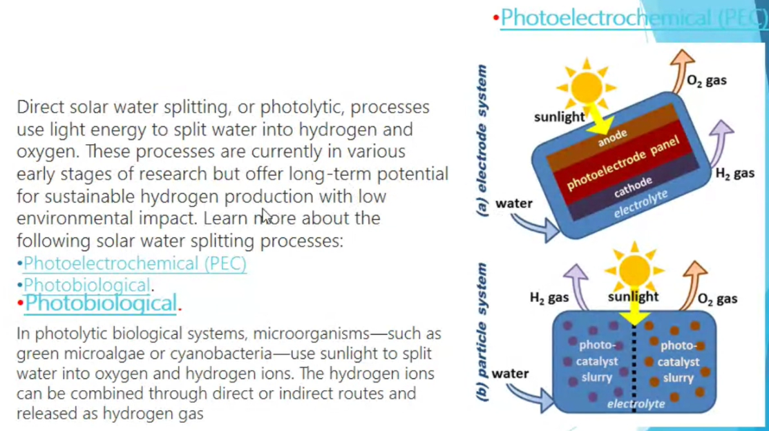
8. Biological Process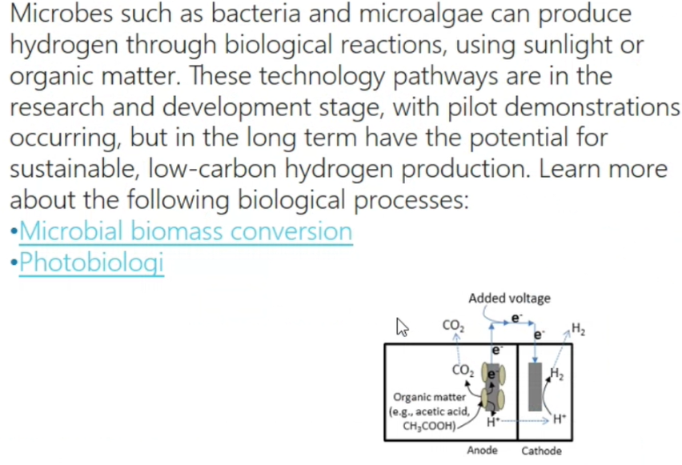

Crystalline Silicon Solar Cell Production:

From Silicon Wafer to Cell

From poly-Si to PV system

1. Why use Silicon? In the crust, the most element is Si, so acturlly the Si is the cheapest matal.
2. The process:
3. From sand to high purity polysilicon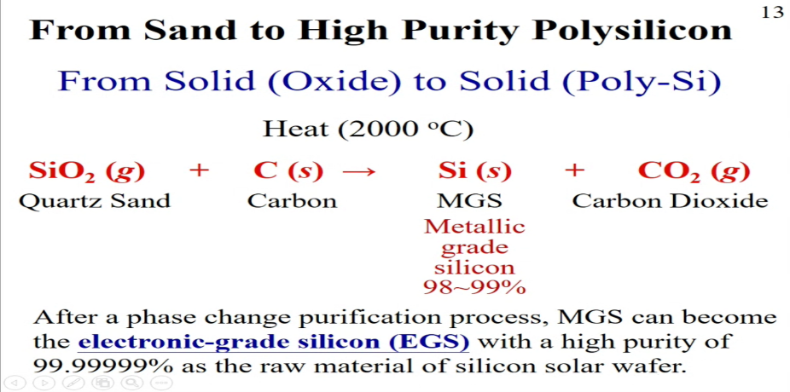
4. Mono-crystal pulling: CZ method

By slow rotation 4~7days, we can get silicon ingot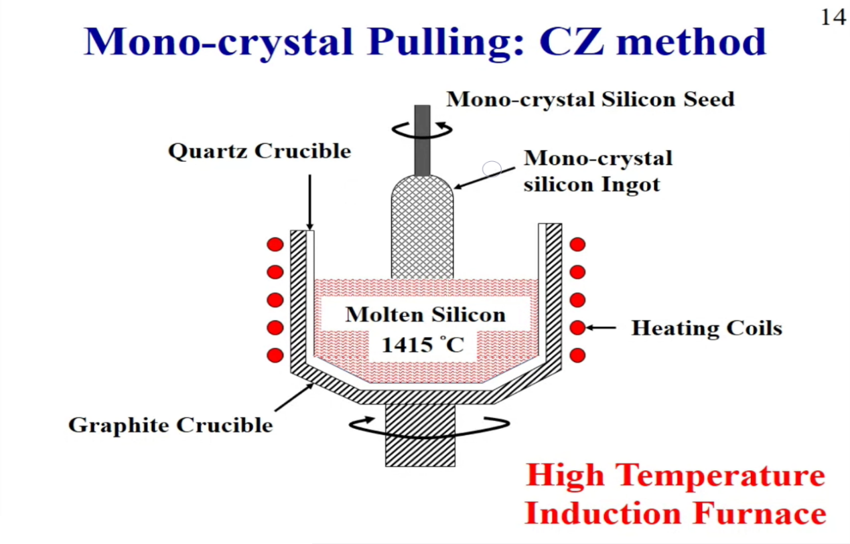

1. Cell process: 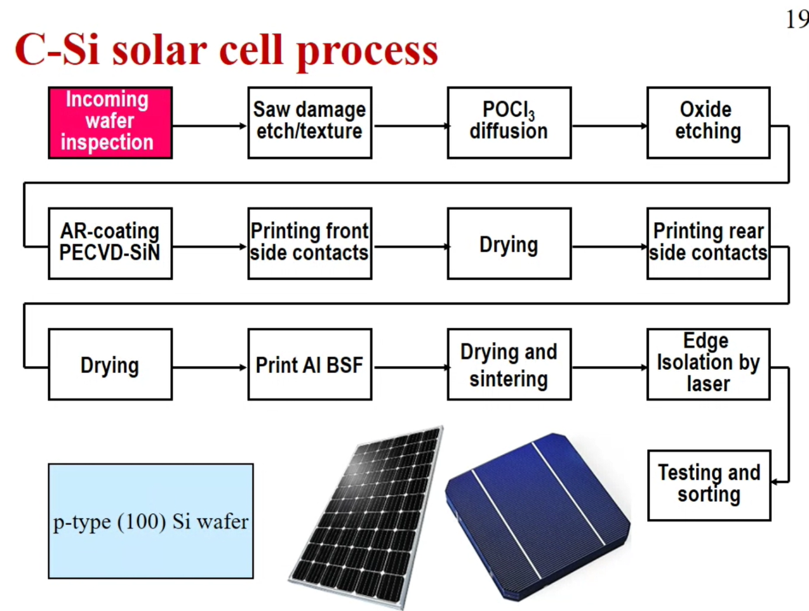
2. C-Si solar cell structure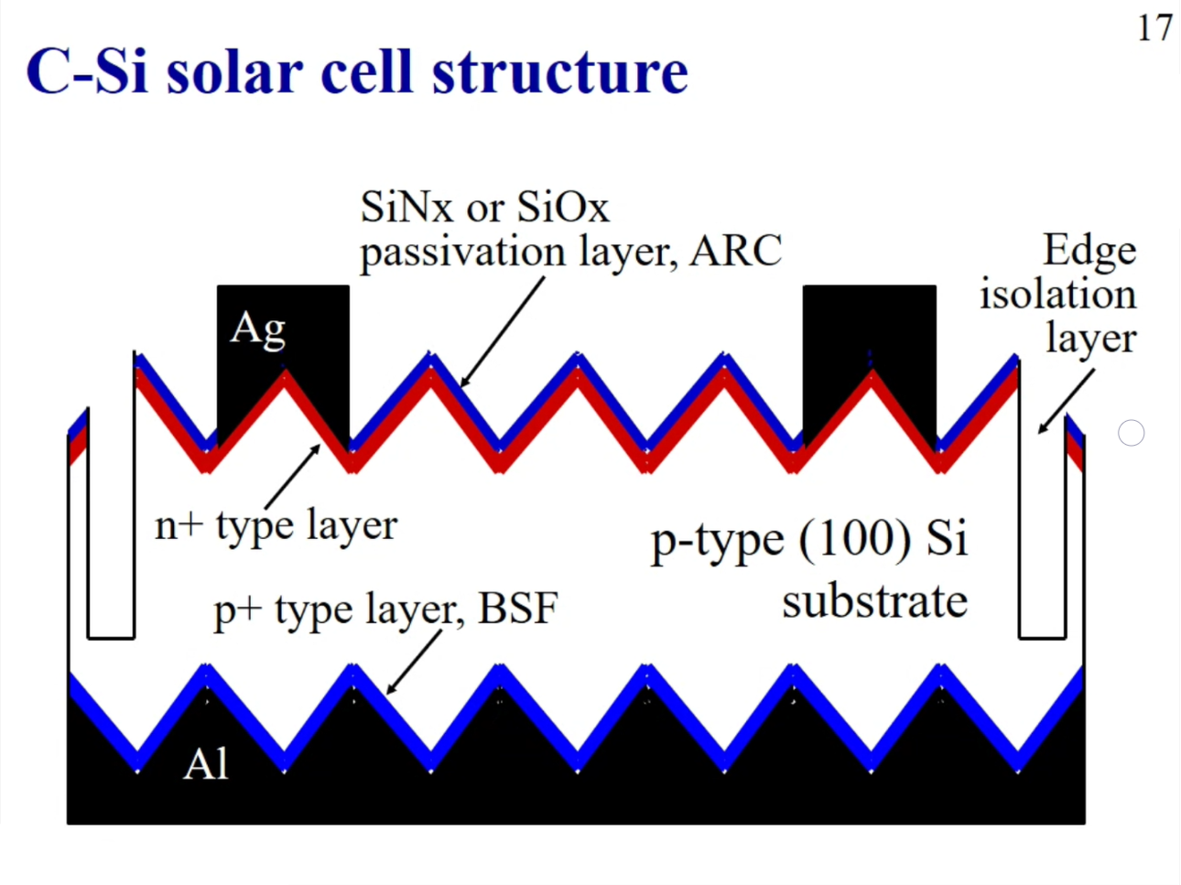

Sonophotocatalysis

1. Sonophotocatalysis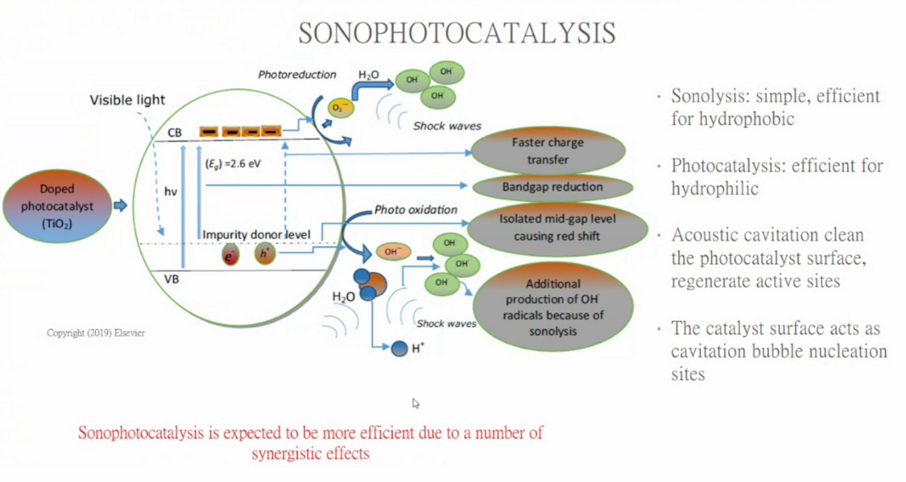
2. Biochar-supported photocatalysts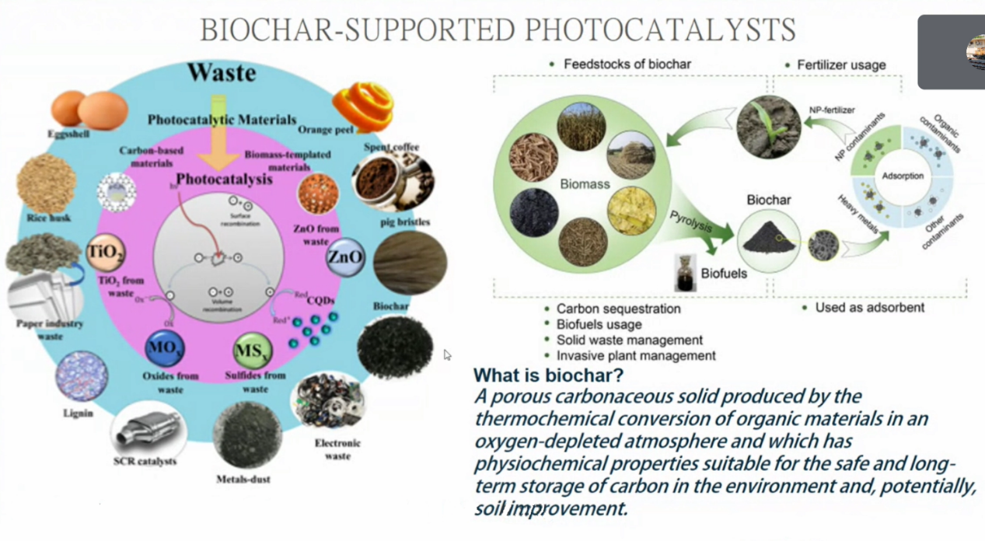
3. Role of biochar in biochar-supported photocatalysts and photocatalysis